SOP for document uploading in Applicant Portal
- Login and Navigation

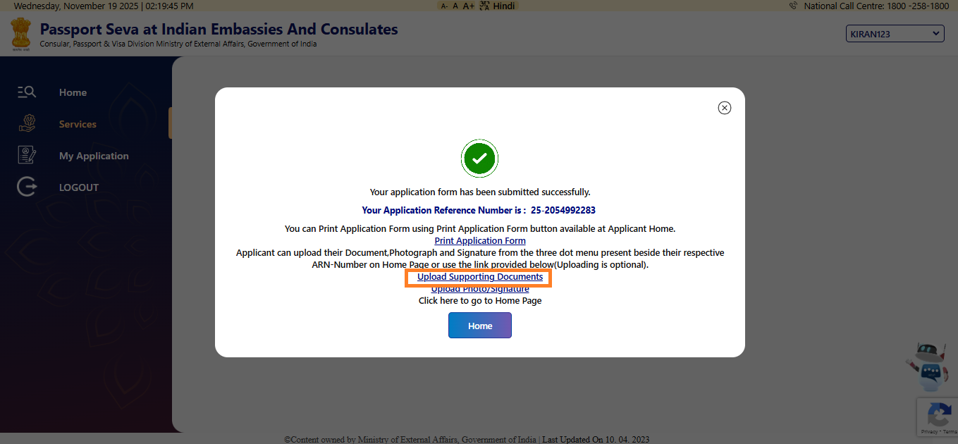

Once the form is submitted, a pop-up message will be displayed. Select “Upload Supporting Documents” to continue with the document upload process.

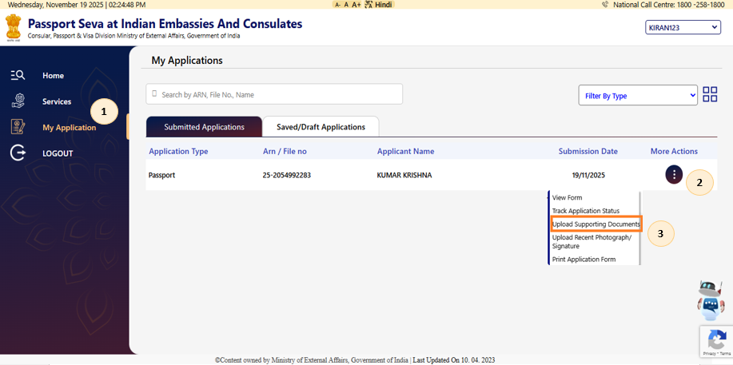

Applicant can click on 1) My Application 2) Select more actions 3 dots 3) choose Upload Supporting Documents

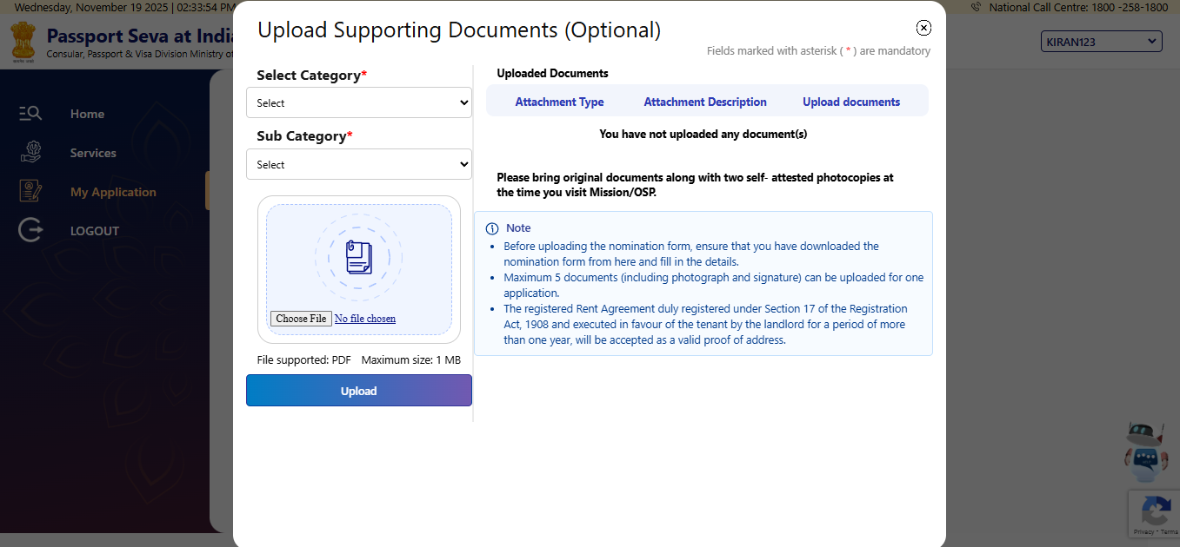

The application will display the document upload page, where you can upload the required supporting documents.

- Document Requirements

- Maximum Size allowed 1 MB
- The total of all uploaded documents should be not more than 1 MB
- Please ensure the document uploaded is in PDF format
- Maximum 5 documents (including photograph and signature) can be uploaded for one application (In Upload Supporting Documents - Only 3 documents can be uploaded).
- The maximum number of attempts allowed to upload documents is 12 (including photograph and signature)
- If the applicant wishes to delete and re-upload the documents, a maximum of 12 attempts is permitted.

- Uploading a Document: Steps to be followed

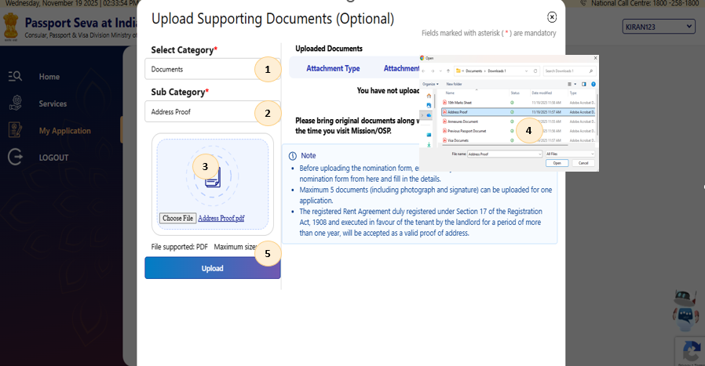

Choose the option to upload a document 1) Select Category 2) Sub Category 3) Click on Choose file 4) Select the file from the local device 5) Click on Upload

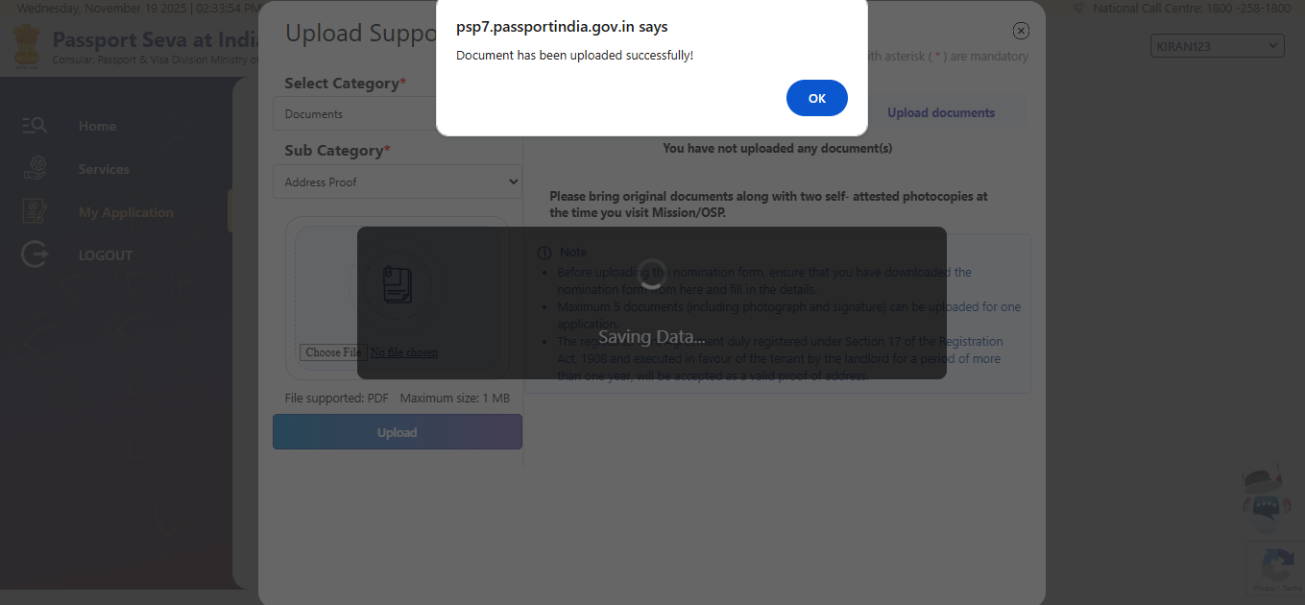

A confirmation message stating “Document has been uploaded successfully!” will be displayed on the screen.

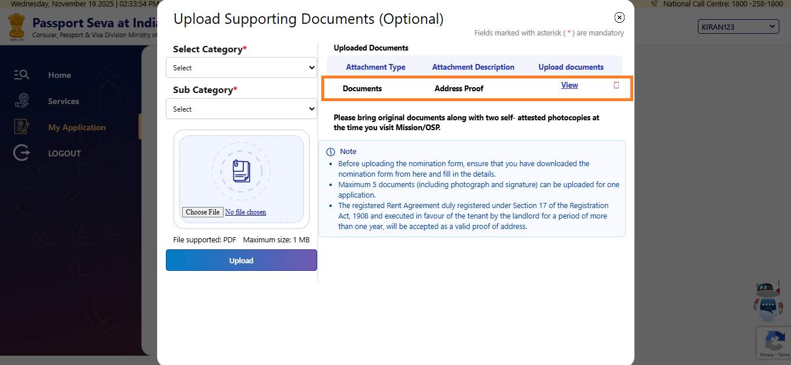

Once uploaded, the document will be displayed on the screen for your review.
Note: The total of all uploaded documents should be no more than 1 MB

- View the Uploaded Document

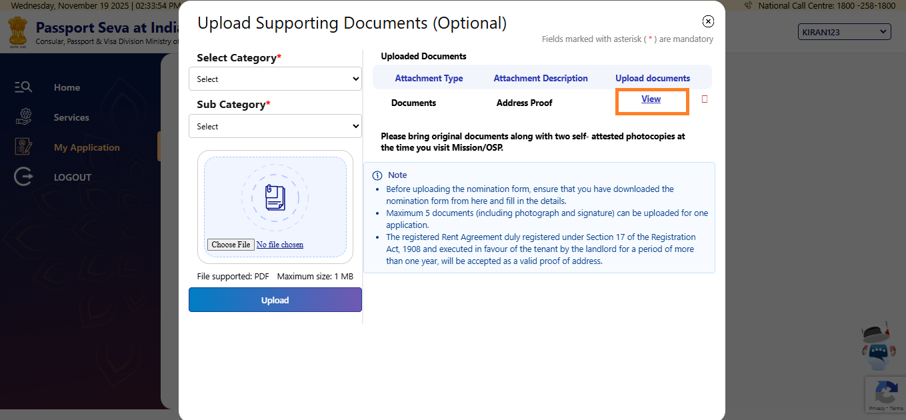

Applicant may click on the View button to access the uploaded document. It will be displayed in a new window.

- Delete the Uploaded Document

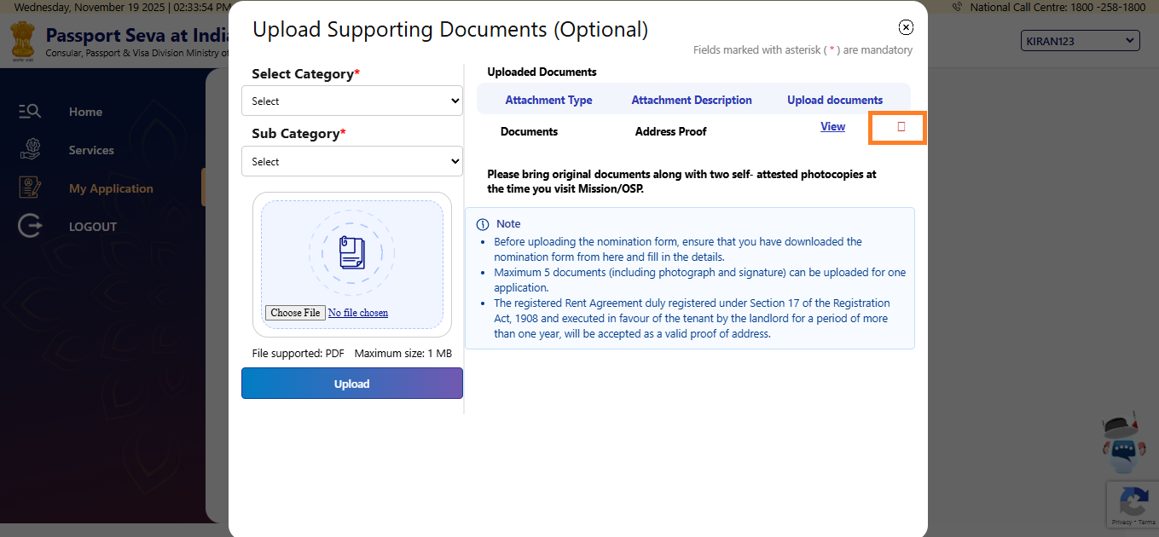

If the applicant wishes to remove the uploaded document, they can do so by clicking the red colored delete button.

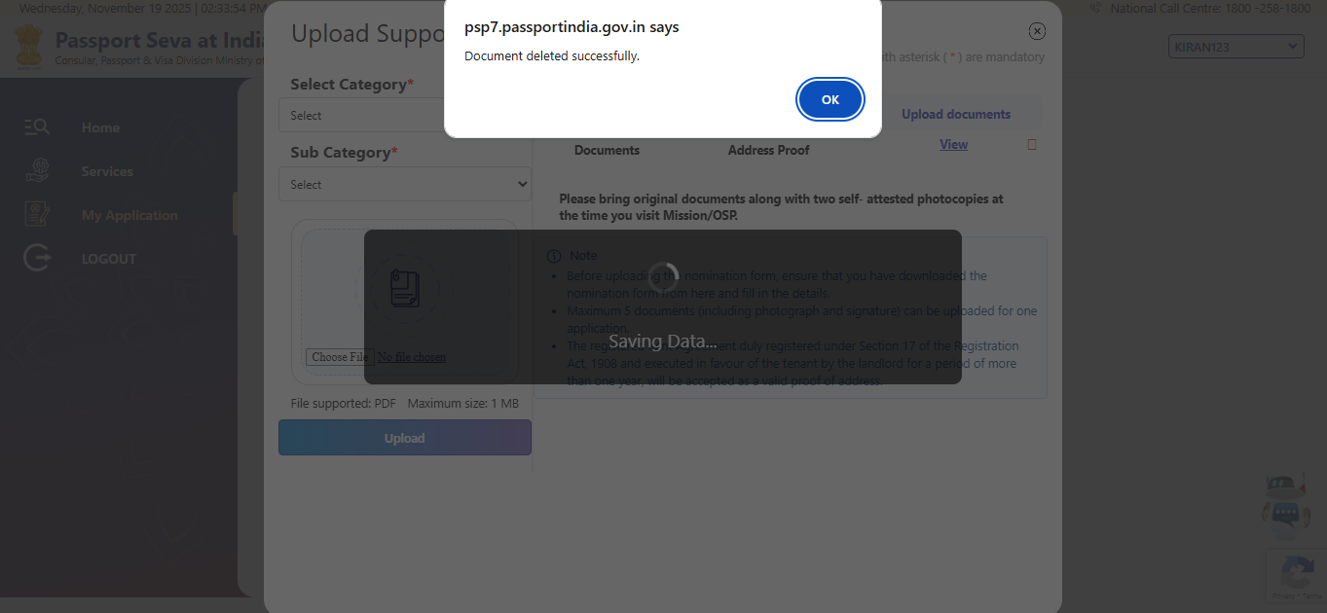

After the document is successfully deleted, a confirmation message stating “Document deleted successfully” will be displayed on the screen.
Note: If the applicant intends to delete and re-upload the documents, a maximum of 12 attempts is permitted (including photograph and signature).

- Error Handling

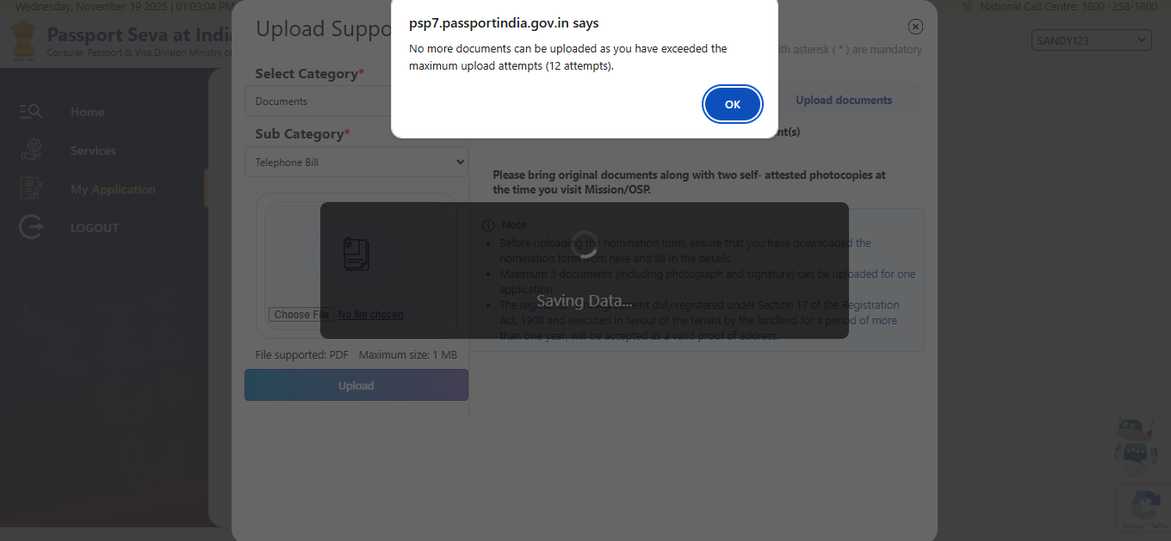

Error “No more documents can be uploaded as you have exceeded the maximum upload attempts (12 attempts)”
Solution: This form should be ignored. The applicant must fill and submit a new form for processing.

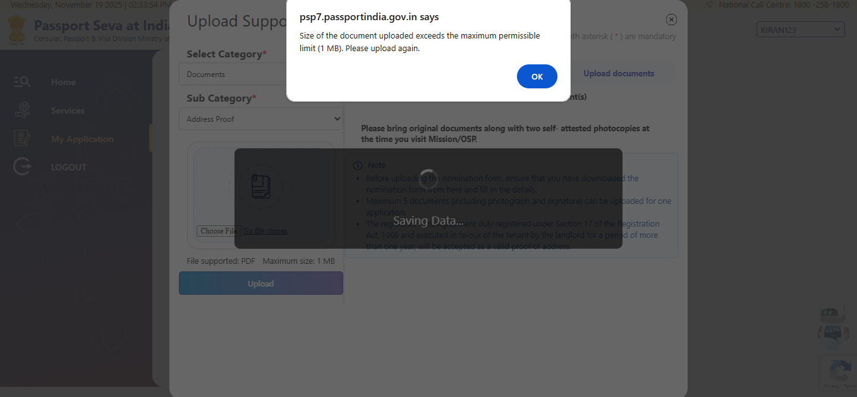

Error: Size of the document uploaded exceeds the maximum permissible limit (1 MB. Please upload again.
Solution: Ensure that the total size of all documents uploaded is not more than 1 MB.

